

Special Discount for
Educators & California Medical Association Members
Fidelity National Insurance believes in the great work that is being done by California Educators and California Medical Association Members. As our way of saying “thank you”, we are pleased to be able to offer you up to a 10% discount, plus up to an additional 25% discount when you insure your home and auto with Fidelity. To find out more about these savings, please call me at the number listed below. I look forward to being of service.
Save Up to 35%* on
Insurance Costs
*10% discount for Educators who are credentialed as a teacher or administrator by the State of California Commission or Teacher Credentialing and hold a 'Clear", "Professional Clear", "Life" or "Preliminary" designation or are employed full-time as a college or university teacher or professor. Proof is required.
*10% discount applies to members of the CMA. Proof of membership is required.
*Up to 25% additional for policyholders with their auto and home with Fidelity.

Arnola Medeiros – (209) 634-6222 – arnola@sbcglobal.net

Barragan Insurance – (916) 984-9320
CA License # OE27354

Fidelity National Insurance Policies Include:
• Home • Fire • Umbrella
• Auto • Rentals • Earthquake
• Renters • Condo • Boat

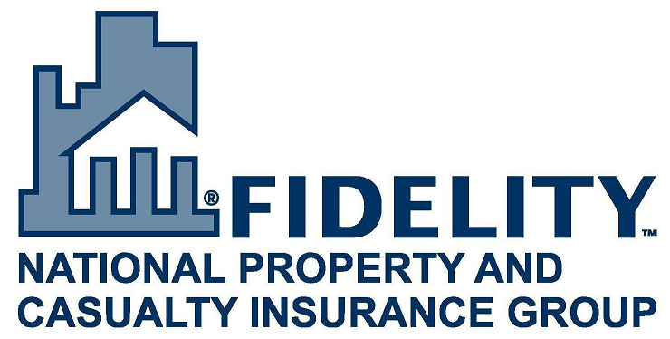

The Fidelity National Property and Casualty Insurance Group’s carriers are licensed in 50 states and offer you great reputation, strength and stability you can count on. We pride ourselves on providing our customers with quick, reliable service to answer questions and resolve claims. The Fidelity National Property and Casualty Insurance Group is rated A- (Excellent) by A.M. Best for exceptional strength and service.

